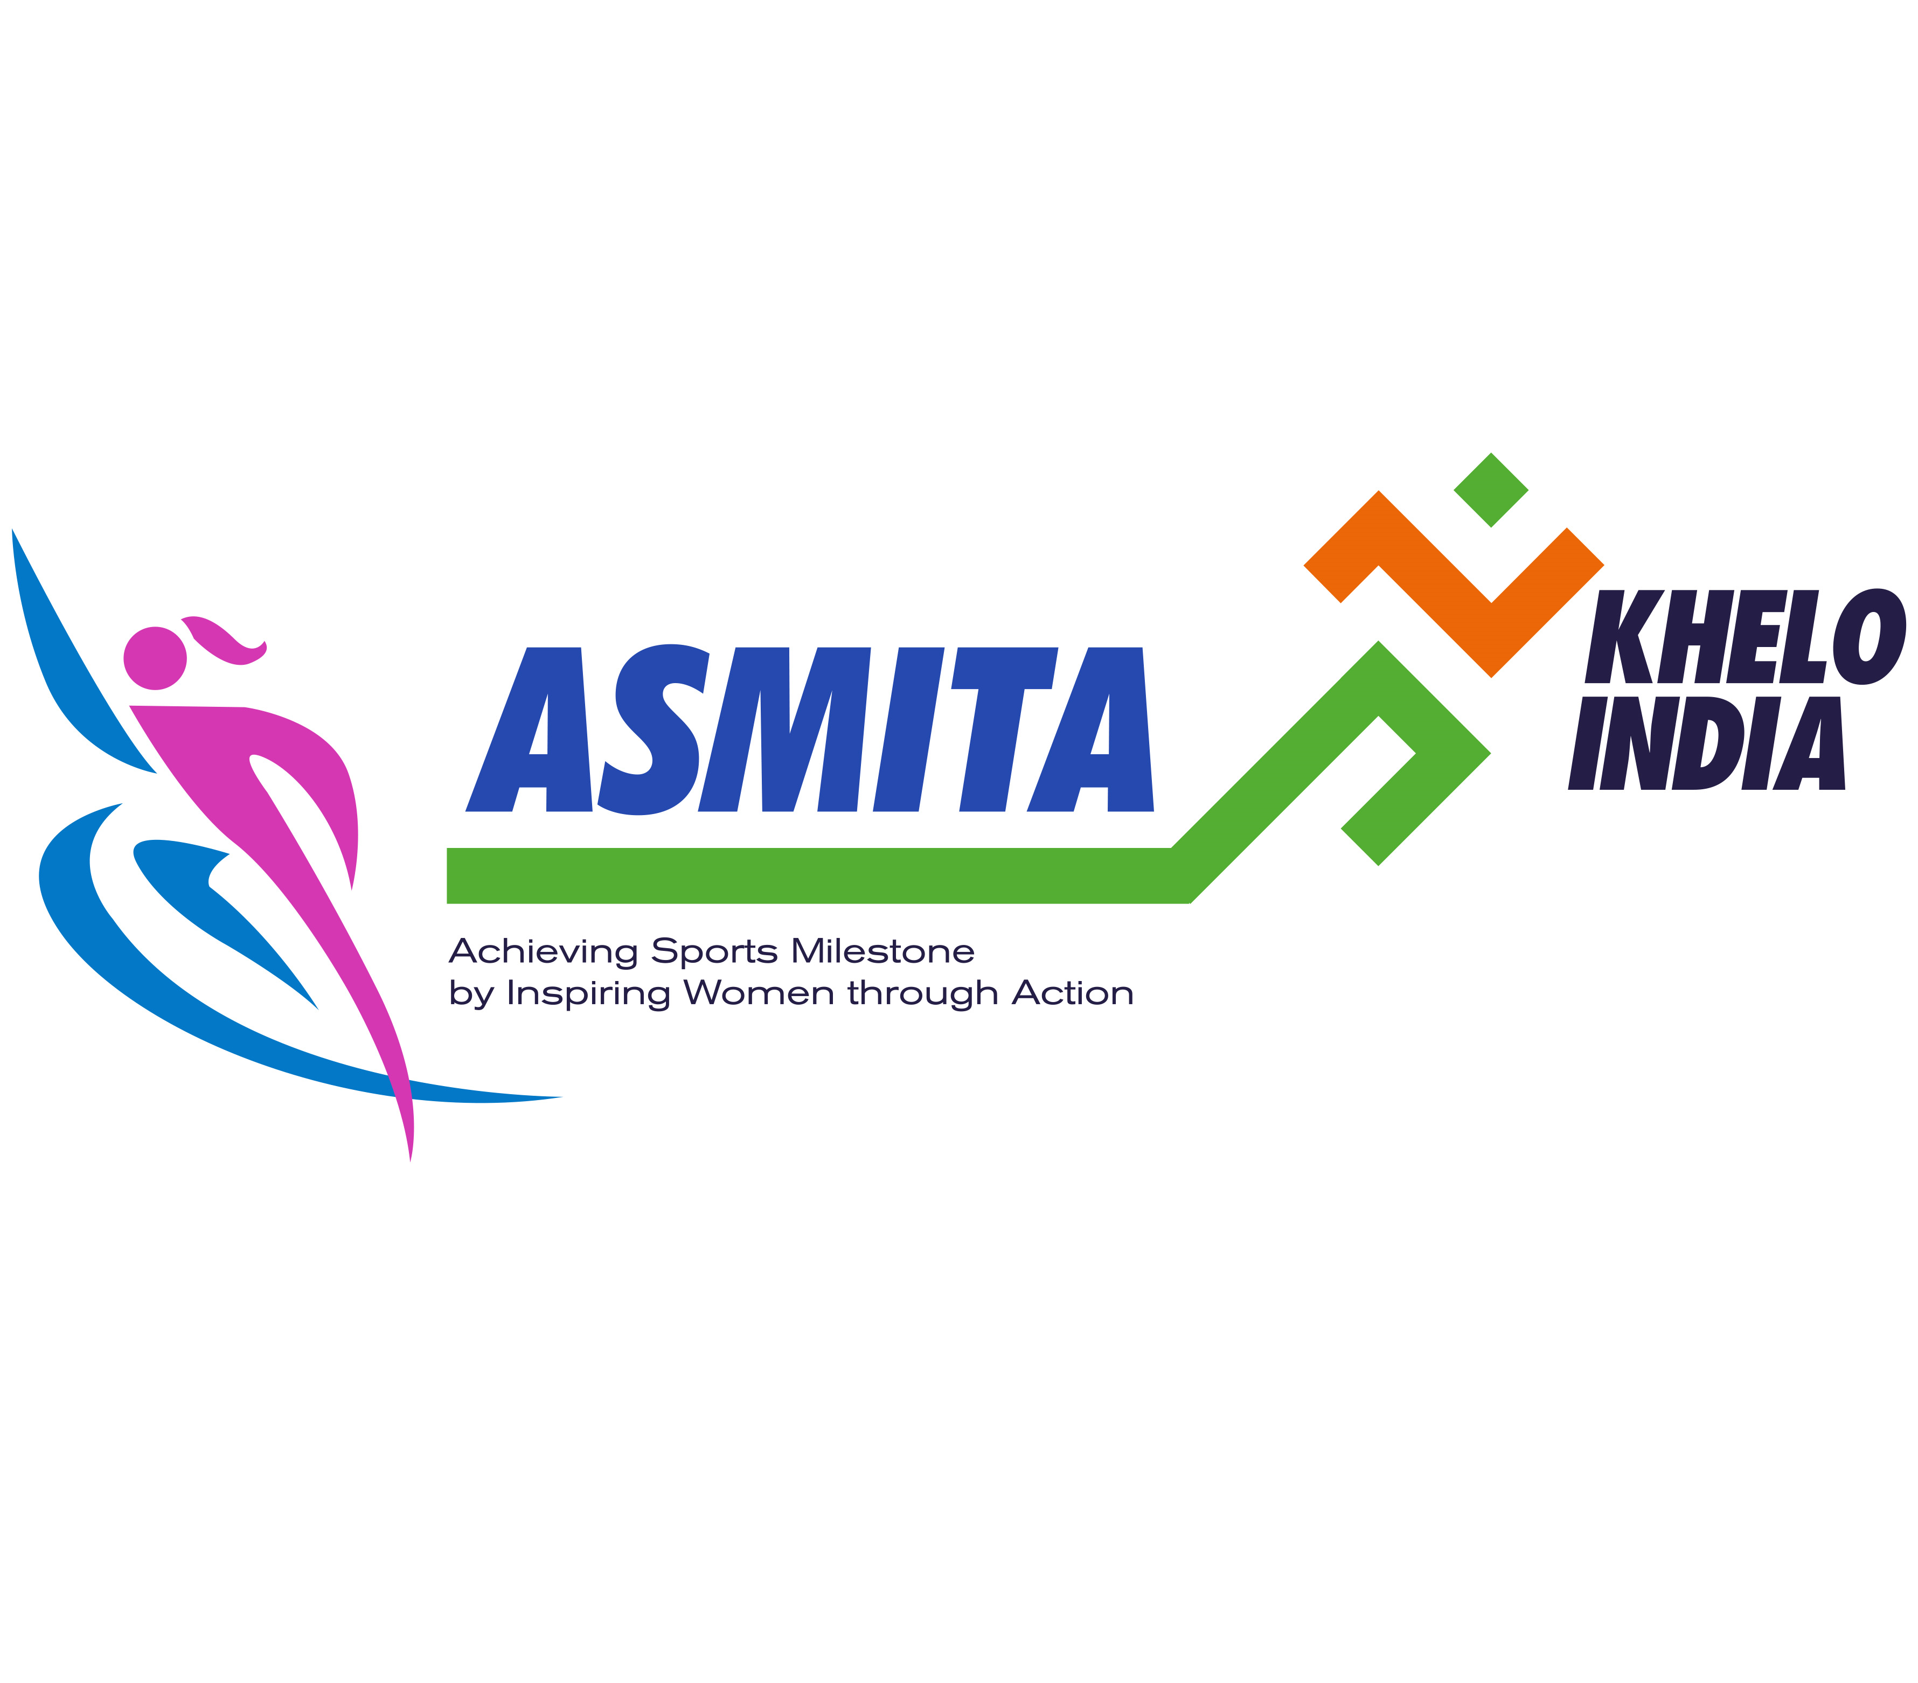
Standard Operating Procedure (SOP) Document for Asmita Women’s League

TABLE OF CONTENTS

Sl No | FUNCTIONAL AREA | PAGE
1 | BACKGROUND | 3
2 | ELIGIBILITY | 3
3 | INDICATIVE SPORTS | 4
4 | ROLES AND RESPONSIBILITIES | 4
5 | BRANDING | 5

- BACKGROUND
The story of women's sports in India is one of aspiration, perseverance, and progress. The emergence of women athletes as formidable contenders in both national and international arenas signifies a profound shift in societal perceptions. The landscape of Indian sports is witnessing an unprecedented surge of talented female athletes breaking barriers, shattering glass ceilings, and pushing boundaries that were once deemed unbreakable. With each remarkable achievement, women in India's sports scene are rewriting the narrative of their capabilities and the nation's potential. The development in women's sports resonates not only as a tale of athletic prowess but also as a celebration of gender empowerment, societal evolution, and the realization of a more equitable future. This pivotal juncture calls for platforms nurturing burgeoning talent. Beyond aspiration, women's sports symbolize determination and resilience. Thus, organizing exclusive sports competitions for women athletes is vital.

We cordially invite all schools, colleges and private & Govt. organizations nationwide to join this transformative journey. By orchestrating exclusive sports events, institutions can not only spotlight athletic acumen but also amplify narratives of empowerment. These contests pave the way for an equitable future, fostering inspiration, breaking barriers, and engendering societal evolution. Together, we champion the empowerment of women in sports and herald an era where limits are redefined.

- Eligibility

Any female player across all age groups may participate in the sports competitions. Efforts shall be made to make the competition more inclusive by allowing female candidates from outside also, who are willing to participate.

- Indicative Sports

The list of indicative sports in which competitions may be organized is mentioned as under, the Organization may decide to include other recognized sports or sports with modified Rules like 5 a side Football, as per local popularity and feasibility.

Archery | Football | Roller Skating
Athletics | Hockey | Mallakhamb
Badminton | Judo | Rowing
Basketball | Squash | Equestrian
Cycling | Swimming | Triathlon
Kho-Kho | Table Tennis | Yogasana
Shooting | Tennis | Wrestling
Softball | Tennis Ball Cricket | Tug of War
Cricket | Baseball | Kabaddi
Soft Tennis | Billiards and Snooker | Golf
Kayaking & Canoeing

- Roles and Responsibilities

- The Organization shall provide for the following:
- Date of the event to be furnished on portal well in advance for vide publicity with details of contact point for participants.
- Make available playfields and sports equipment as per requirement.
- Technical conduct of Sports competition. Organization can ask District Sports federation for help in Technical conduct of Event.
- Marketing and publicity of the event including branding at the venues.
- Conduct sports presentation and award Certificates/ Prizes to the winners.
- Felicitation of women achievers from the State/District.
- Facilitate coverage of the event across national/regional/local and Social media.
- Organization may garner sponsorship for conduct of the event.
- Participation/ Winner certificates can be downloaded from portal by organization after uploading details of tournaments and Participants, which can be circulated among athletes on the concluding day of competition after getting a color print.
- Certificate for appreciation (for institution only) can be downloaded from portal.
- Talented players can be identified and particular of the players can be filled in the column on portal.
- Good quality Pictures and Videos showing athletes in action shall be uploaded on Asmita Portal.
- Report on the media coverage in national/regional/local level along with photographs/videos of the event and links for the social media handles (wherever pictures/ videos are posted) may be forwarded to Khelo India on sfw.kheloindia @gmail.com.

- The SAI shall provide for the following:
- SAI shall provide branding templates which shall be adhered during the competition for branding, marketing, Signages etc. Branding template can be downloaded from portal.
- SAI shall Provide Certificate template for certificates.
- SAI Social media handles will give wide publicity to Pictures/ Videos and tournament as and when details are received from organization.

- Branding & Marketing Guidelines
Branding is an integral part of any sporting competition, including competitions held under Khelo India. The significance of Khelo India’s brand name and logo are key assets around which Khelo India tries to build strong relationships with the general public and participating entities. Branding elevates the look and feel for the entire game.

Branding:
- University/College/Institution to ensure only the approved Composite Logo is used for all branding purposes.
- The name of the competition shall mandatorily include key words like “Asmita Womens’ League / Competition / Tournament”
- Size of Khelo India and Asmita logo shall not be smaller than any other logo.
- Appropriate branding of Field of Play.
- 50% of the branding will be available to University/College/Institution.
- University/College/Institution to do Khelo India branding on the remaining 50% space.
- The participating teams will be allowed to have the logo on their apparel.

